**Phase1 Assignment**

**Objective -** To Create a blogging website for general purpose use where a user can post the blogs and at large users can make use of it

**Design Approach –** Used HTML,CSS, JS and Bootstrap for designing and used basic layout structure

**Git URL -** [**https://github.com/shivagupta189767/MEAN_STACK_PHASE1**](https://github.com/shivagupta189767/MEAN_STACK_PHASE1)

**Index.html** – home html page and user lands up in home page on click of it

**Index.js –** this is a js file and has logic for processing of post of blog

**Style.css –** contains styling

**About.html –** contains html for about page

**Categories.html –** contains html for categories page

**Website frontend design –**

**Home Page**

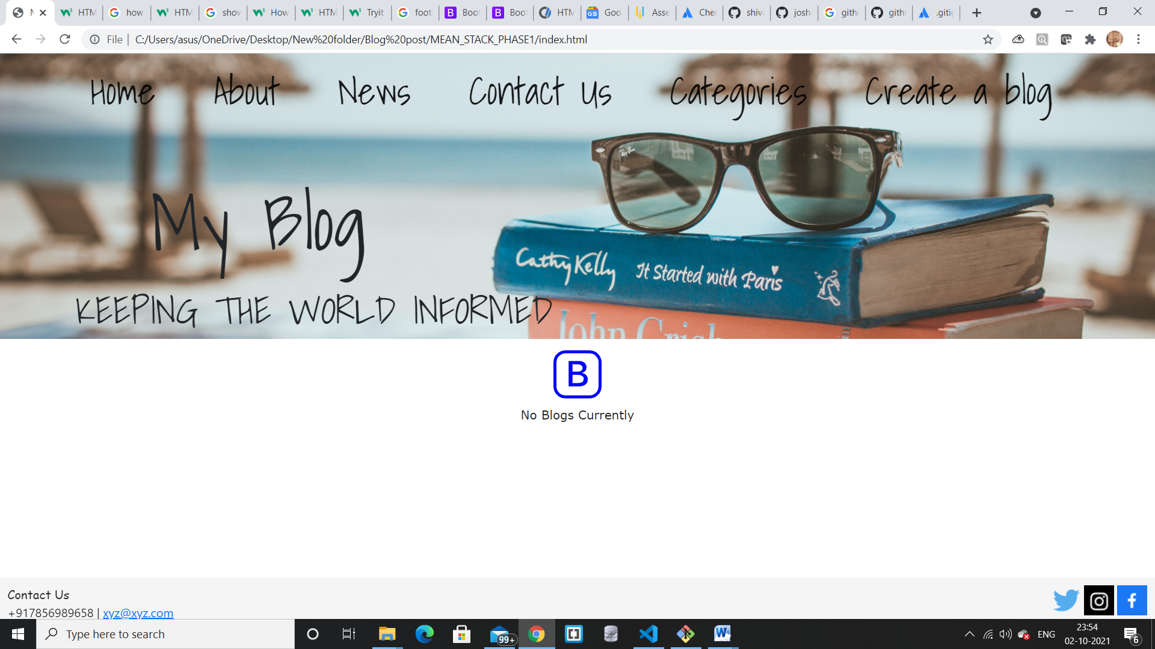

**About Page**

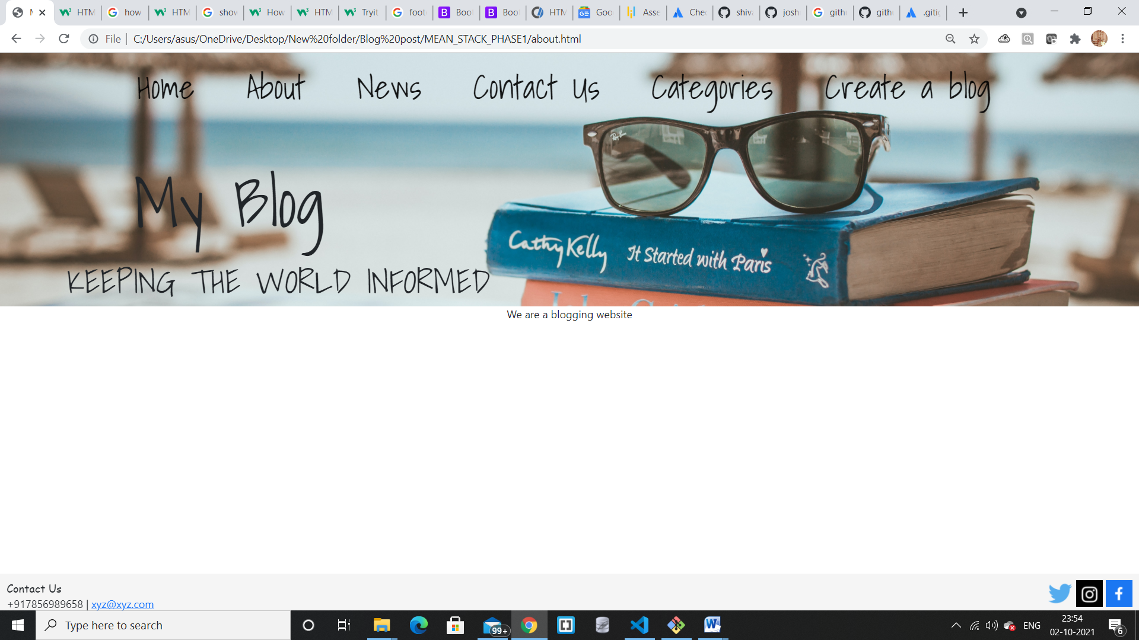

**News page takes you to google news in new tab**

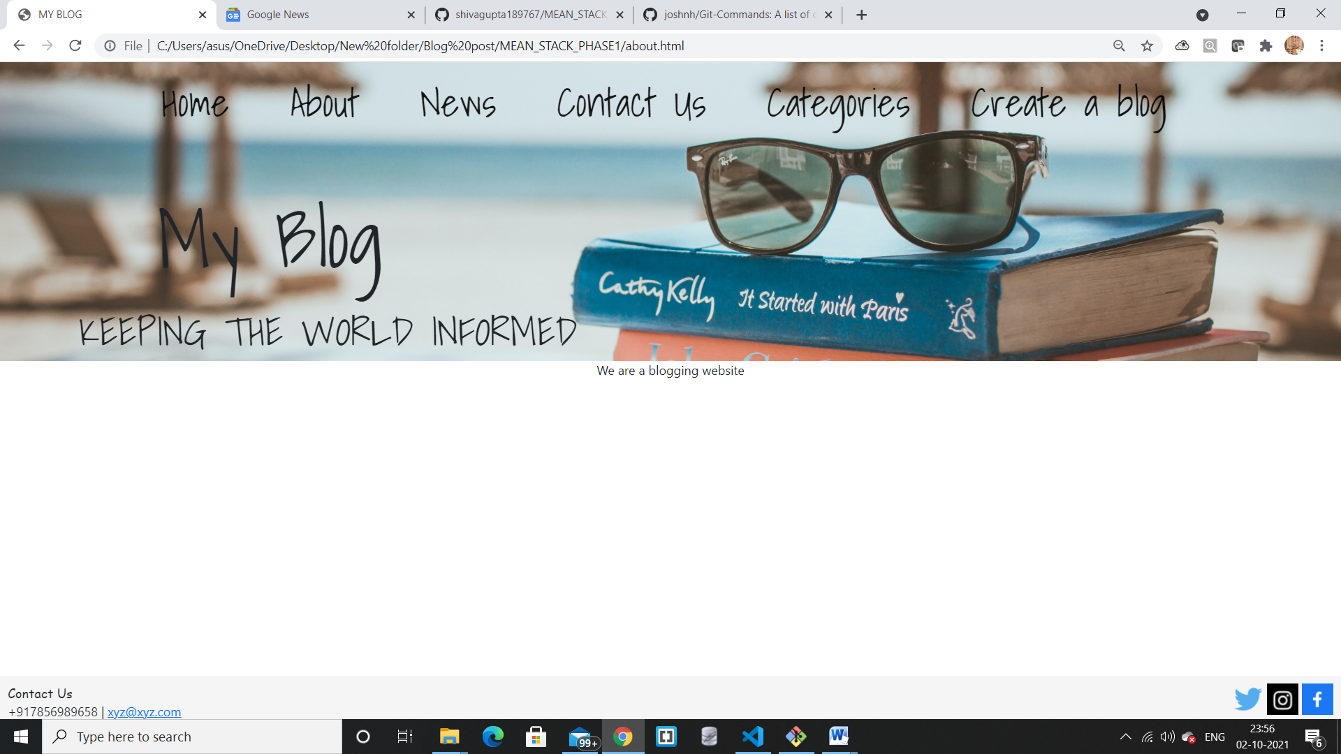

**Contact Us – links to the footer of the page**

**Categories Page –**

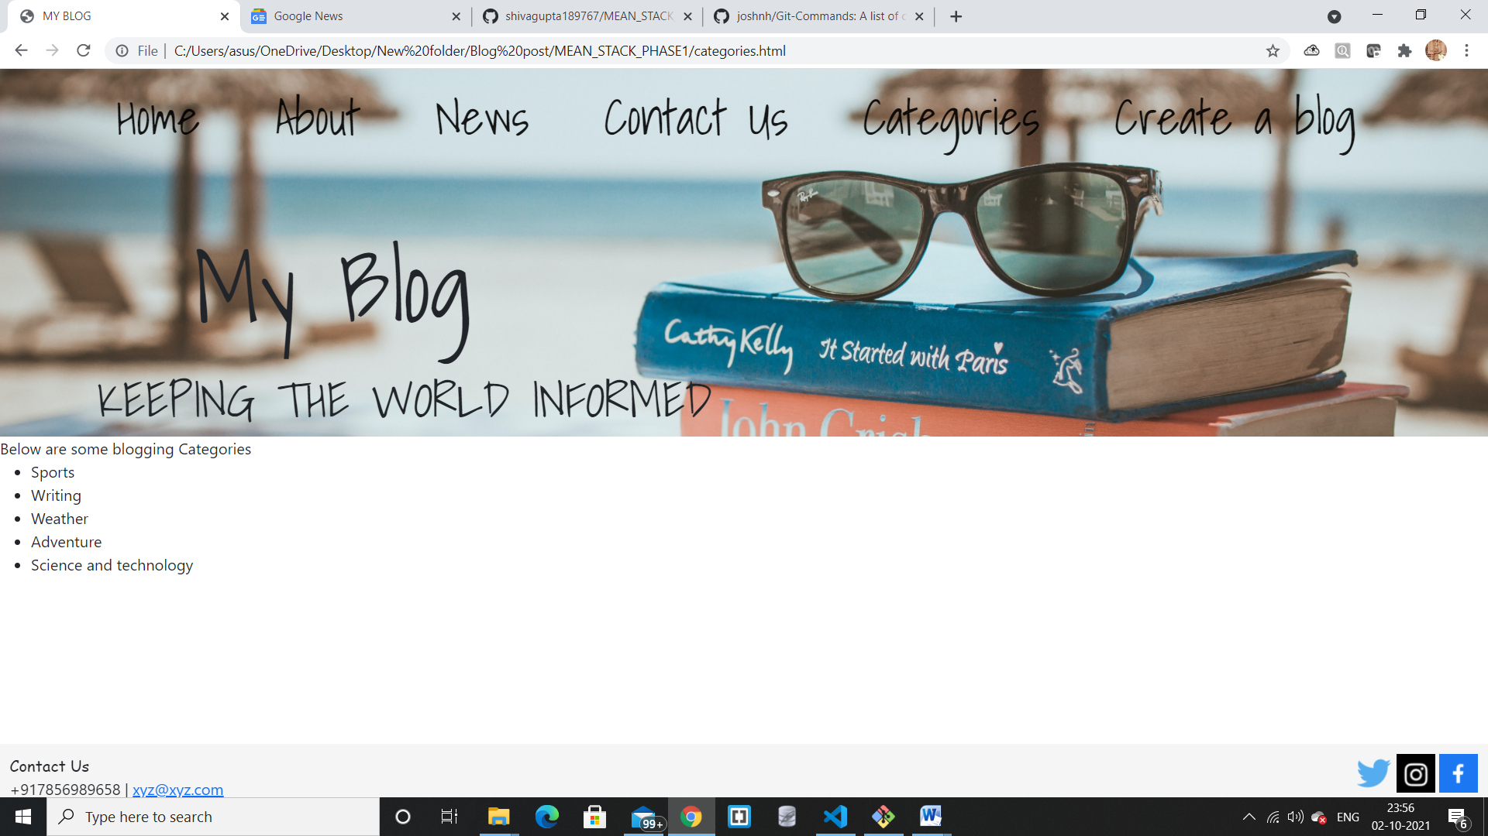

**Create a Blog Button –**

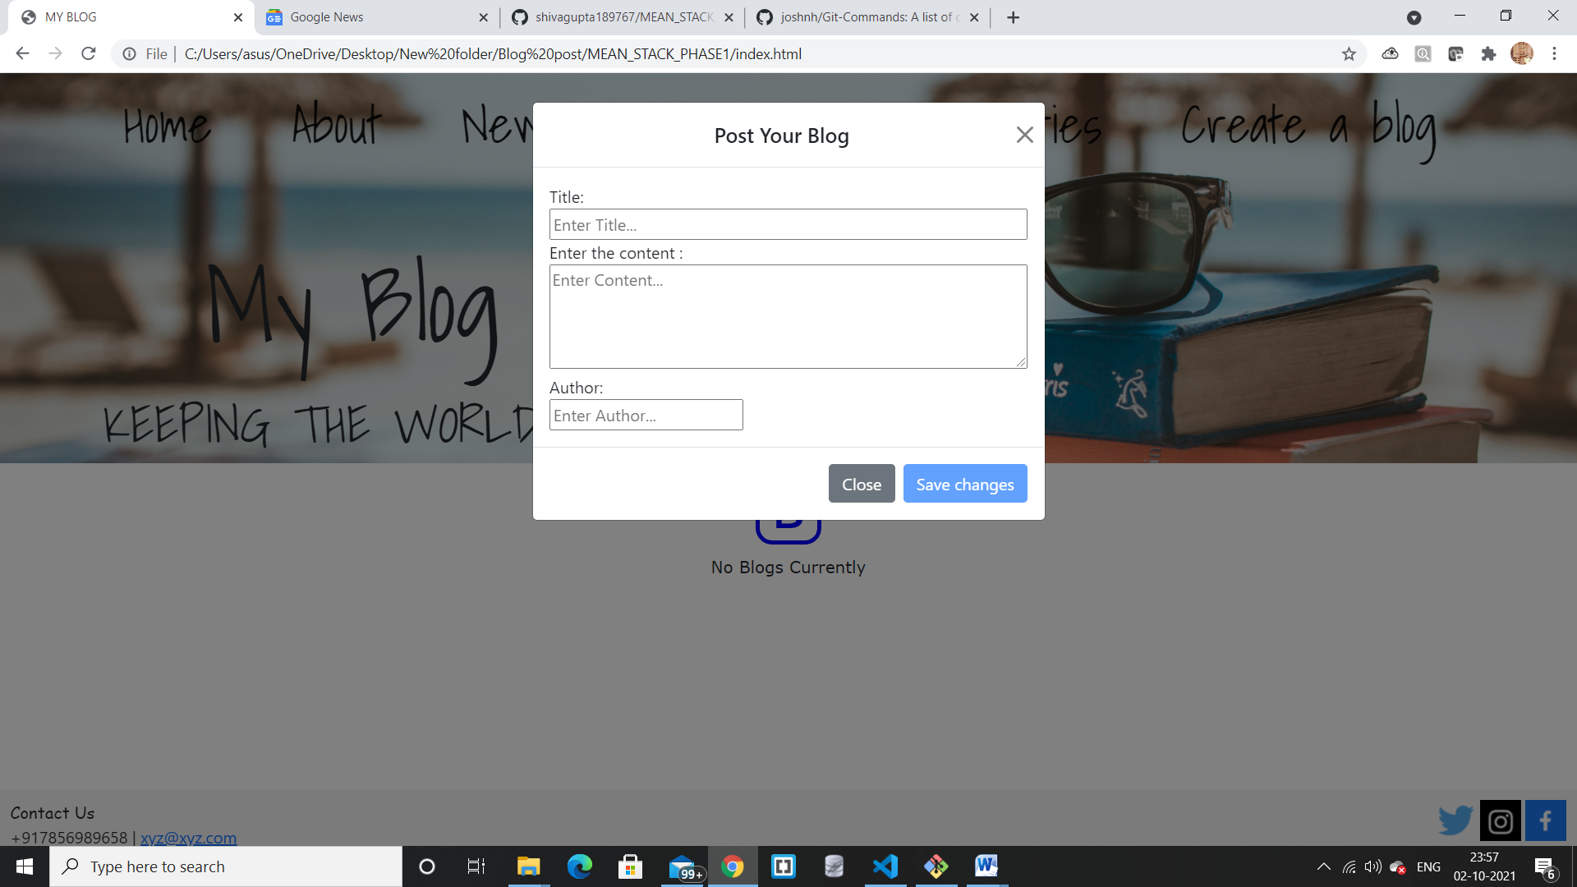

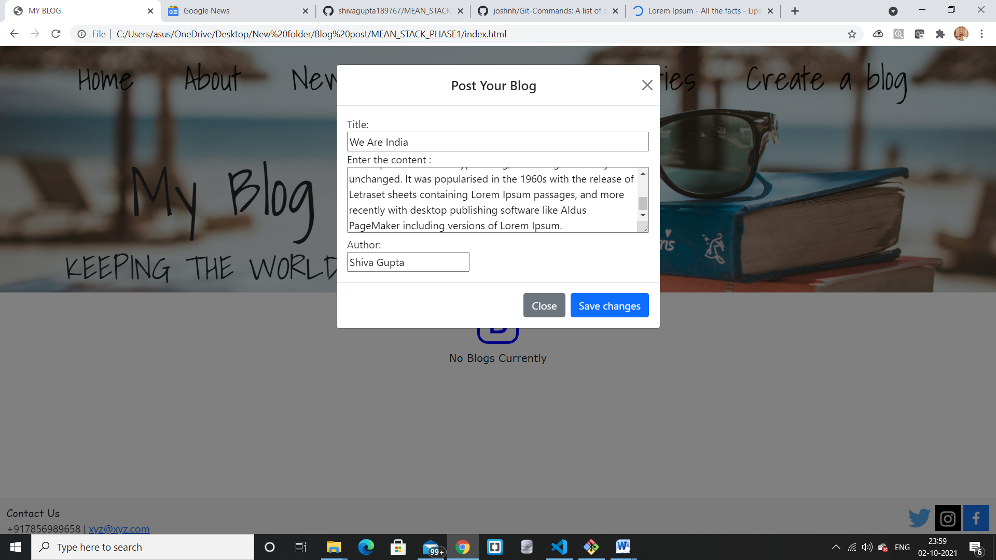

**Here by default all fields are empty and save changes button is disabled as soon as user fills all the required details save changes button get enable and user see below type of layout**

